https://themefisher.com/best-free-html5-templates/:
Fornax - Corporate Site Template
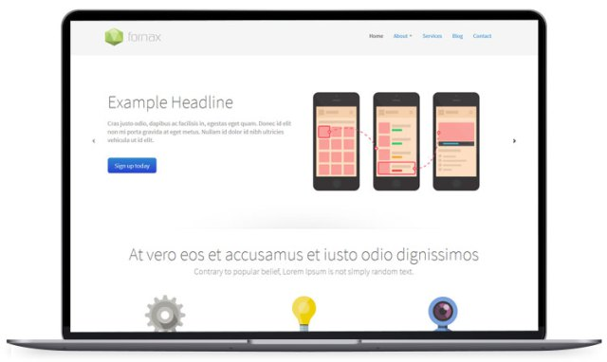
Fornax is bootstrap landing page template for the corporate website with minimal design. The template is highly customizable and indispensable for those who would like to begin and kick-start their personal and business website.


